**Homework Assignment 4 – BUSINESS ANALYTICS. Solutions.**

1. Consider your payoff as the sum of the year 1 and year 2 revenues (and potential costs). What is the Maximax strategy? Provide a table to justify your answer. *Hint: make sure you have considered all possible states in your payoff table.*

The two-year payoffs table is as follows (also see attached Excel Spreadsheet for details).

|  |  |  |  |  |  |
| --- | --- | --- | --- | --- | --- |
| TWO YEAR PAYOFFS | | | | | |
|  | Market and Competitor Response | | | | |
|  | Good, | Fair, | Good, | Fair, | Poor |
|  | no lawsuit | no lawsuit | lawsuit | lawsuit |  |
| No new ad campaign | 200 | 120 | - | - | -15 |
| It’s toasted | 400 | 100 | 350 | 87.5 | -60 |
| The World is Dangerous | 600 | 80 | 525 | 70 | -150 |

Using the Maximax strategy, we will select the choice with the highest highest profit (calculate the highest number for each row, and then choose the highest of those numbers):

|  |  |
| --- | --- |
|  | Highest |
|  | Profit |
| No new ad campaign | 200 |
| It’s toasted | 400 |
| The World is Dangerous | 600 |

We will choose **“The world is dangerous”.**

1. What is the maximin strategy? Provide a table to justify your answer.

Using the Maximax strategy, we will select the choice with the highest lowest profit (calculate the lowest number for each row, and then choose the highest of those numbers):

|  |  |
| --- | --- |
|  | Lowest |
|  | Profit |
| No new ad campaign | -15 |
| It’s toasted | -60 |
| The World is Dangerous | -150 |

We will choose **No new ad campaign**

1. What is the minimax regret strategy? Provide a table to justify your answer.

We need to calculate the regret table first:

|  |  |  |  |  |  |
| --- | --- | --- | --- | --- | --- |
| REGRET TABLE | | | | | |
|  | Market and Competitor Response | | | | |
|  | Good, | Fair, | Good, | Fair, | Poor |
|  | no lawsuit | no lawsuit | lawsuit | lawsuit |  |
| No new ad campaign | 400 | 0 | - | - | 0 |
| It’s toasted | 200 | 20 | 175 | 0 | 45 |
| The World is Dangerous | 0 | 40 | 0 | 17.5 | 135 |

Then we will select the choice with the lowest highest regret (First, calculate highest number in each row and then pick the lowest of the three).

|  |  |
| --- | --- |
|  | Highest |
|  | Regret |
| No new ad campaign | 400 |
| It’s toasted | 200 |
| The World is Dangerous | 135 |

We will choose **“The world is dangerous”.**

1. What is the maximum expected payoff strategy and what is the expected revenue under this strategy? Justify your answer with a table or with a decision tree. If you use a decision tree, you may use any program such as Powerpoint, Excel, OneNote or Paint to represent your decision tree. You may even draw it on paper, neatly scan it, and attach it to the homework. The main thing is that it is understandable. Points will be deducted if it’s not clear what’s being represented.

|  |  |  |  |  |  |  |
| --- | --- | --- | --- | --- | --- | --- |
| TWO YEAR PAYOFFS | | | | | | |
|  | Market and Competitor Response | | | | |  |
|  | Good, | Fair, | Good, | Fair, | Poor | Expected |
|  | no lawsuit | no lawsuit | lawsuit | lawsuit |  | Profit |
| No new ad campaign | 200 | 120 | - | - | -15 | 95.5 |
| *Probability* | *0.2* | *0.5* |  |  | *0.3* |  |
| It’s toasted | 400 | 100 | 350 | 87.5 | -60 | 105.125 |
| *Probability* | *0.1* | *0.35* | *0.1* | *0.15* | *0.3* |  |
| The World is Dangerous | 600 | 80 | 525 | 70 | -150 | 101 |
| *Probability* | *0.04* | *0.3* | *0.16* | *0.2* | *0.3* |  |

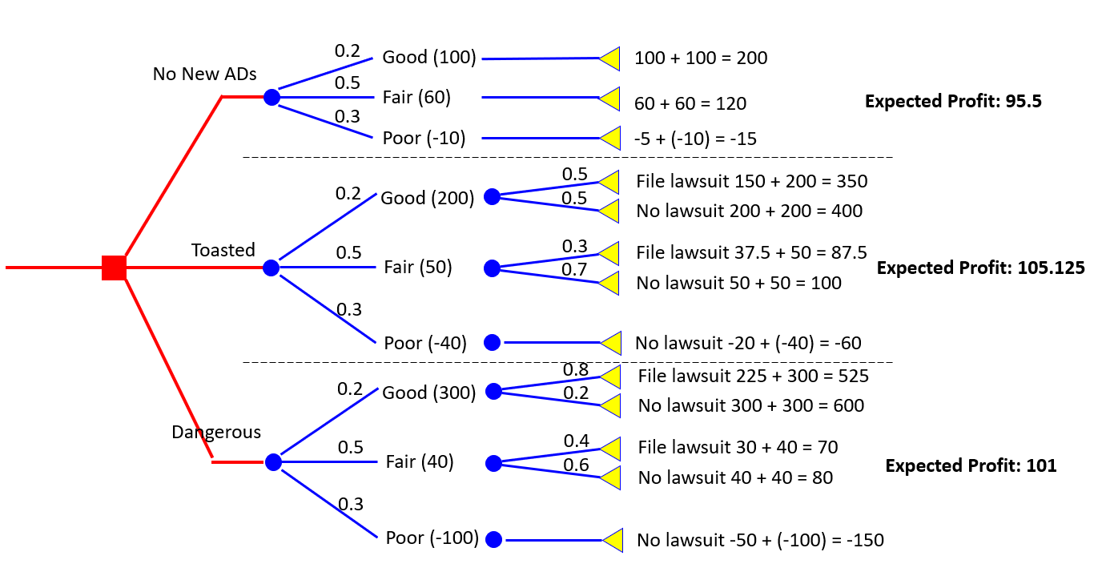

For example, for “No New Ads” Expected payoff is equal to: 0.2*200 + 0.5*120 + 0.3*(-15) = 95.5, and similarly for the remaining two decision alternatives. If we choose the strategy with the highest expected payoff, we will choose **“it’s toasted”** and it will have an expected payoff of 105.125